**STANDARD INTEGRATION FORMULAS:**

1. ***Integration of Algebraic Functions***
3. ***Integration of Logarithmic and Exponential Functions***

1. ***Integration of Trigonometric Functions***
2. ***Integration of Inverse Trigonometric Functions***

**Activity #1**







**Activity #2**



**Activity #3**

**Activity #4**

**Integral Calculus** is the inverse of differentiation or simply known as anti-derivative. Integral Calculus is supposed of two major areas

**1) The Indefinite Integrals** such as direct methods of integrations and techniques & integration and

**2) The Definite Integral**

**INDEFINITE INTEGRAL**

**DEFINITE INTEGRAL**

**STANDARD INTEGRATION FORMULAS:**

1. ***Integration of Algebraic Functions***

***Ex. Evaluate the integral of the following:***

1. **{ *FOIL Method* }**

**Exercise:**



***Apple u - substitution:***

1. ***Integration of Logarithmic and Exponential Functions***

**Rational function**



1. ***Integration of Trigonometric Functions***
2. ***Integration of Inverse Trigonometric Functions***

**Sample Problems:**

Apply Trigonometric Substitution

Use the common integral

Simplify:

Rewrite using trig identities

Apply u-substitution:

Use the common integral

Apply u-substitutio

Take the constant out:

Use the common integral:

Substitute back:

Add a constant to the solution

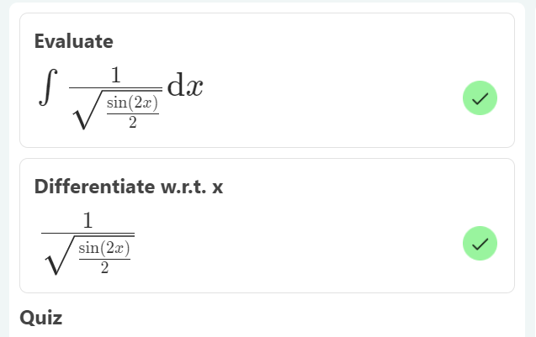

Apply u-substitution:

Apply the Power Rule:

Substitute back:

Use the basic trigonometric identity:

Apply Trigonometric Substitution:

Apply the Sum Rule

Substitute back:

Add a constant to the solution

Rewrite using trig identities

Apply u-substitution:

Take the constant out:

Rewrite using trig identities

Apply the Sum Rule

Substitute back:

Simplify:

Add a constant to the solution

Rewrite using trig identities

Expand:

Apply the Sum Rule

Simplify

Add a constant to the solution

Apply u-substitution:

Take the constant out:

Apply u-substitution:

Take the constant out:

Use the common integral:

Substitute back:

Simplify

Add a constant to the solution

Apply Integration By Parts

Simplify

Add a constant to the solution

Rewrite using trig identities

Take the constant out:

Express with sin, cos

Use the common integral:

Simplify

Add a constant to the solution

Take the constant out:

Rewrite using trig identities

Take the constant out:

Rewrite using trig identities

Use the common integral:

Simplify

Add a constant to the solution

**+c**

Simplify

Rewrite using trig identities

Take the constant out:

Apply u-substitution:

Take the constant out:

Apply u-substitution

Apply the Power Rule:

Substitute back

Simplify

Add a constant to the solution